COLORADO STATE SQUARE DANCE FESTIVAL
GATSBY’S ALIVE IN 2025

June 13 & 14, 2025
Friday - Saturday
Featured Caller |  | Featured Cuers
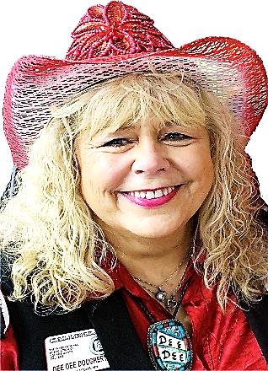 | GOOGLE MAP IT  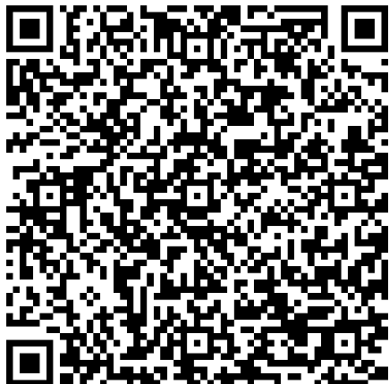  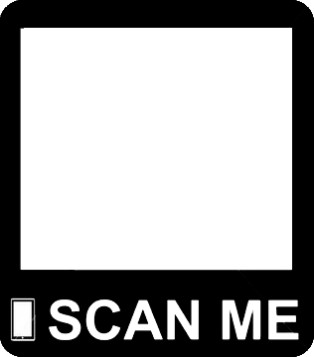  COLORADO MESA UNIVERSITY  (University Center)  1455 N. 12th Street  Grand Junction, CO 81501 | 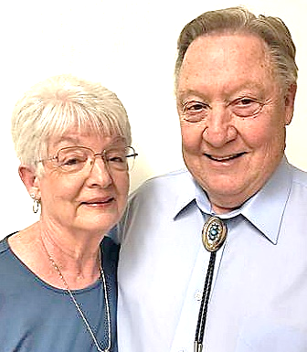
DEE DEE DOUGHERTY-LOTTIE |  | LARRY & SUSAN SPERRY

For more information: Pat & Wanda McBride  970-434-3543  Email: pandapw3138@gmail.com |  |  | 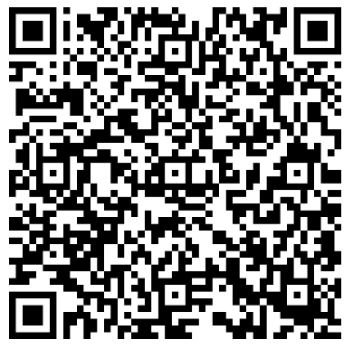  GOOGLE LODGING MAP
Festival Website Here |  | Pre-registration Form
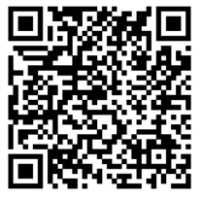 | 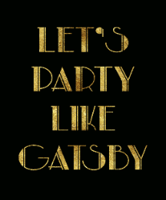  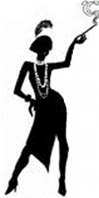  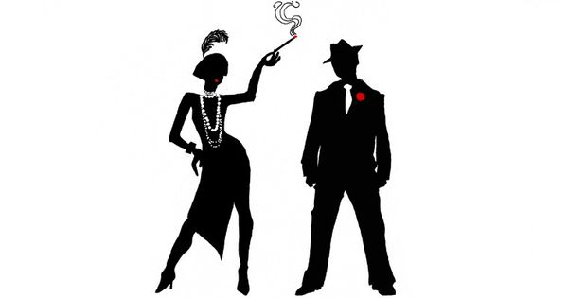 | 