Final Report to:
The Colorado State Square Dance Assn.
and
The Mountain and Plains Square Dance Council

The 66th Colorado State Square Dance Festival
June 10 – 11, 2022
The University of Northern Colorado
Greeley, CO

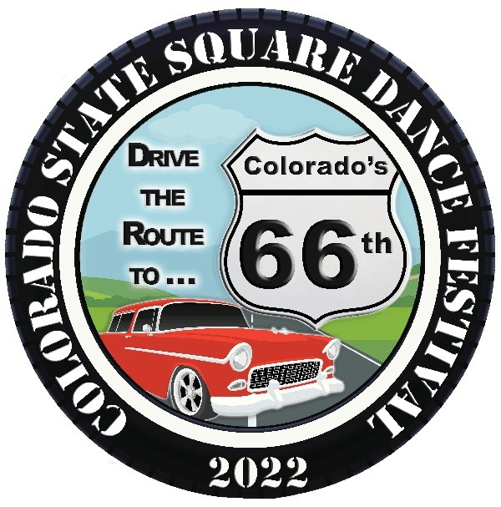

Submitted by: Dennis & Barbara, Chairpersons
Accomplished by: The 66th Square Dance Festival Committee
August 24, 2022

We got our kicks at Colorado’s 66th!

Table of Contents

Page

Chairpersons’ Report …………………………………………………………………. 3

Appendix A Final Report (CSSDA Format) ………………………………………. 6

Appendix B Registration Forms …………………………………………………… 8

Appendix C University of Northern Colorado Documents
- Invoice from UNC Conference Services ………………. 9
- Letter to UNC Staff ……………………………………. 11
- Strengths & Weaknesses of Facility & Staff ………….. 12

Appendix D Vendor Applications …………………………………………………. 14

Appendix E Facilities Documents
- Committee Report ……………………………………… 17
- Overall Festival Floorplan ……………………………… 18
- Lounge/Hallway Floorplan …………………………….. 19
- Ballrooms Floorplan …………………………………… 20
- Meeting Rooms Floorplan ……………………………... 21
- Stage Set-Ups ………………………………………….. 22

Appendix F Dance Program Planning Documents
- Pocket Program for the Weekend ……………………… 23
- Planning Matrix for Square Dance Program …………... 24
- Planning Matrix for Round Dance Program …………… 25

Appendix G Budget vs. Actual Statement – FINAL ………………………………. 26

Chairpersons’ Report - Colorado State Festival 2022

Introduction

This report is the final act we take to complete our responsibilities as chairpersons for the 2022 Colorado State Square Dance Festival of 2022. It has been an awesome journey and we are honored to have been entrusted with the job. Our intent in writing this document is not simply to meet the stated reporting requirements, but to give the reader a full understanding of the route we travelled and, hopefully, share some kernels of wisdom and insight that might help future leaders. We are thankful for the many blessings we experienced in this job, and especially for the hard work, determination, endurance, and tenacity of the 2022 Festival Team. We couldn’t have asked for a better group of folks with whom to have travelled the Route to Colorado’s 66th!

Background/History

We were asked by the Mountains and Plains Square Dance Council (MAPSDC) to join the team for the then 2021 State Square Dance Festival in 2018 as associate chairpersons. The chairpersons at that time were Jeff and Kris Nance. These were the pre-COVID days when we believed that we would be following the normal rotation of festivals among the Colorado councils. Our work as associate chairs was to aid the chairpersons in researching potential venues for the 2021 festival. The University of Northern Colorado had been the site of the last MAPSDC state festival and was a leading candidate for a repeat. We still looked at a number of alternative sites in our process, including hotels in Ft. Collins, Greeley, and Loveland. We also researched Colorado State University in Fort Collins as a possibility and assisted the Nances in the formation of the Festival Team and the theme for the 2021 Festival.

As our work continued into 2020, two major challenges arose that would influence our plans. First, the Nances determined that they would be unable to continue as chairpersons, but would move to the assistant role. We were asked by MAPSDC to move up to the top job; we accepted the offer. Second, the pandemic hit and changed not only our plans for the festival, but also the whole world. We watched as the folks in the Colorado West Council first postponed their festival from 2020 to 2021, then ultimately asking CSSDA for permission to cancel altogether. Their festival would have been the 65th. Since our theme was intimately tied to being “Colorado’s 66th”, we petitioned CSSDA to allow the records to show the 65th as canceled with its number and keeping our festival the 66th. That was granted.

Planning for a large get-together in the midst of a pandemic is one of the strangest and challenging situations ever! COVID 19 was the biggest public health emergency to hit the world since the Spanish Flu of 1918. For most of 2020 and 2021, we were on the brink of falling into cancelation just like our predecessors. There was much trepidation on the part of the square dance community about their safety. At one point, the entire world economy seemed to be in shut-down mode! We selected UNC as our venue to be. We waited as the University went through times of mandatory masking and social distancing on campus. Either of these policies would be impossible to implement for the Festival. On-campus housing and food service were also in jeopardy. Through it all, however, we continued to plan as if by 2022 things would improve and the Festival would indeed happen.

Our original Festival Budget called for 500 registrants and revenue of $47, 520. This was a retreat from the 2017 Festival that saw over 600 registrants. We had no assurance that even a decrease of 17% in projected registrations could be achieved. The wild card was, of course, the pandemic. Our first glimmer of hope came in January of 2022. A combination of variables kicked in: widespread vaccinations, lowering of risk factors, lifting of social distancing requirements, lifting of mask requirements on campus at UNC, and the resumption of square dances around the state. There were encouraging trends, but predicting how many participants we might have remained a daunting task! We continued to work with UNC to scale our facility requirements to a sustainable level. We revised our expectations downward and set a goal for 350 registrations. We felt that we could “break-even” with that number. Also, active promotion of the 2022 Festival truly began!

The advantages of the current system of Festival rotation among the four Colorado square dance councils are: 1) work can start on your Council’s next Festival right after you complete your current one, 2) you have three years to get all the work done, 3) your theme is in place and promotional materials are ready long before your Festival, and 4) your Festival team can actively promote the next summer’s Festival at the current year’s event. Getting registrations at the front end of your Festival’s scheduled year is tremendously advantageous! You can get some cash in the bank and begin to build momentum toward the next June. It also allows for distribution of promotion boards to clubs around the state and scheduling of in-person promotion at dances throughout the state. Unfortunately, Colorado’s 66th got short-changed on the process due to the pandemic. The 65th was scrapped, so we couldn’t promote at the preceding Festival. Most clubs in the state were not dancing until January 2022 or later, so promotional dances got squeezed into a much smaller window of time.

Summary and Description of Report Components

Despite the obstacles, the 2022 Festival Team managed to hold a very successful Festival on June 11th and 12th in Greeley! Appendix A is the Colorado State Square Dance Festival 2022 – Final Report Form (per the CSSDA’s Procedure and Policy Sheet 2 of 17 – Exhibit 3). We fell short of the 500 dancers we projected, but managed to secure 407. All four state Councils were well represented with the Denver Area leading the way with 178 (43.7% of total); MAPSDC with 120 (29.5%), the Southeast with 43 (10.6%); Colorado West with 28 (6.9%); eleven (11) other states also sent a total of 38 dancers (9.3%). See Appendix A for details of the Festival including: dance package data, RV Parking, Catering, Housing, Vendors, Facilities, Promotion, Program, Committee Activities, and Final Accounting.

Our outstanding Registration Documents are included in Appendix B. The wrap-up with our host, The University of Northern Colorado, is featured in Appendix C. Our final invoice totaled $14,291.67 with a deposit of $765.38 having been made earlier in the process. Total payment to UNC was $15, 057.05. We felt very positive about our experience with UNC this year. In our closing conference with University officials, we shared the many strengths we noted about our experience. We also shared a number of issues that fell into the weaknesses category. Both lists are in Appendix C. Based on the weaknesses, we formally requested a discount on our invoice from UNC in the amount of $1,536.00; our request was granted.

Past Festivals have experienced robust participation from outside vendors. We were able to attract three (3) vendors at our 2022 Festival. Their application information is shown in Appendix D. Vendors included: a water filtration service, handmade jewelry, and Linda Goble’s “Yellow Rock Closet”, featuring clothing.

We were especially blessed with a Facility Committee chairperson with a passion for facility planning – Tom Roepke. Tom left nothing to chance in his drawings and specifications for the setup of the University Center for our Festival. He worked hand-in-hand with the staff at UNC and the physical aspects of the setup and use were flawless. His drawings of the UNC floor plans are in Appendix E.
The intricacies of building square and round dance programs are many and complicated. Securing the featured caller and cuers is just the tip of the iceberg. Managing the plethora of local callers and cuers, juggling the facilities to maximize use, installing and testing sound equipment, and making sure that all the participants are having fun…these are the jobs of the Program Committee Chairs! We were fortunate indeed to have Roger Schappell and Dave Smith heading up the square and round dance duties, respectively. Their work came to fruition at the two days of fun in Greeley! The planning documents they used to pull it off are in Appendix F. We’ve enclosed the “Pocket Schedule” given to all dancers. Also, the detailed spreadsheets that accounted for every minute of square and round dancing are included. The square dance doc is “Route 66 Draft Matrix (Version 6.7). The round dance doc is entitled “Route 66 Round Dance Program Schedule”. Review of these documents will give you an appreciation of all the work our two dance leaders did!

Last, but certainly not least, the 2022 Budget vs. Actual Statement (or “P&L”) for Colorado’s 66th is included as Appendix G. Our original budget projected a revenue of $47, 520. That was based on 500 dancers. We ended up with 407 dancers, so our actual revenue was $36,378, or $11,142 less than budget (-23.4%). The frugal mindset our Committee, however, allowed us to scale and control costs and keep them in line with lower participation and revenue. The Festival’s general expenses (facilities, housing, meals, etc.) were budgeted at $25,865, but we held those costs to $17,682.55. That was $8,182.45 under budget (-31.6%). Committee expenses were equally impressive! Those expenses were budgeted at $12,508.50 and came in at $10,2637.55, or under budget by $2,240.95 (-17.9%). Total expenses were $27,950.10 or $10,423.40 less than the $38,373.50 budgeted! We were under budget by 27.2%! The bottom line for the Festival shows a profit of $8,427.90! This means that our Festival Treasurer will be sending checks to both CSSDA and MAPSDC for $4,213.95!

Closing

The 2022 Colorado State Square Dance Festival was the first one to be held since June of 2019…three years coming! It was a transitional festival, but it got us back on track after a long pandemic layoff. Numbers were down from what we anticipated, but we all had a great time and it was a financially solvent venture. Considering what we’ve gone through as an activity and a nation in the past three years, it was a minor miracle. Our thanks again go to the dynamite team we had the pleasure and honor to lead! This wouldn’t have happened without them!

Respectfully submitted,
Dennis & Barbara
Dennis & Barbara Miller
Co- Chairpersons

Appendix A

COLORADO STATE SQUARE DANCE FESTIVAL 2022 – FINAL REPORT FORM
(CSSDA Procedure and Policy Sheet 2 of 17 – Exhibit 3)

Hosting Council: Mountains and Plains Square Dance Council (MAPSDC)
Festival Dates: June 11-12, 2022
Festival Location: University of Northern Colorado - Greeley, CO
Festival Theme: Drive the Route to Colorado’s 66th

1. REGISTRATION DATA
a. Early Registrations: 111 Pre-Registrations: 272 At The Door: 24 Total: 407
b. Dancer Distribution (Councils and Other States)
• Totals from CO Councils: Colorado West 28, Denver Area 178, Mountains & Plains
120, Southeast Area 43; Total in-State: 369
• Total from Other States: AL, AZ, CA, FL, MT, NE, NM, SD, UT, WI, and WY = 38

2. DANCE PACKAGE PRICES
a. (See attached Registration Form)
b. Registration Income Sources:
• Early Registration (Full Package) $ 5,550.00
• Pre-Festival Registrations (Full Package) $14,630.00
• At-Door (Full Package) $ 1,440.00
• Friday Only $ 200.00
TOTAL DANCE PKG. INCOME $21,820.00
(Note: All registered were adults; no youth)

3. RV PARKING
a. RV Parking Nights: 40 Nightly Price: $20.00
b. Total Income from RV Parking: $800.00

4. CATERING
a. Prices for Ala Carte Meals: Breakfast $9.45 Lunch $11.45 Dinner $12.45
b. Full Package Cost (1 Breakfast, 2 Lunches, and 2 Dinners) = $46.00
c. Total Packages Sold: 104 Total Income: $4,784.00

5. HOUSING (Dormitories)
a. Suite Charge/night: $120.00
b. Total Suite Nights: 54
c. Total Income: $6,720.00
d. Total Cost: $4,685.00

6. VENDORS
Copies of Vendor Applications attached (3)

7. FACILITIES
a. Copy of Final Invoice from UNC attached
b. Copy of Festival Floorplans attached
COLORADO STATE SQUARE DANCE FESTIVAL 2022 – FINAL REPORT FORM
(CSSDA Procedure and Policy Sheet 2 of 17 – Exhibit 3)

8. PROMOTION
a. Publicity and Promotion materials and mileage: $1,641.21

9. PROGRAM
a. Square Dance Program
* Featured Caller: Charlie Robertson $1,800.00
* Caller Travel $ 438.52
* Meals $ 46.00
* Lodging $ 337.02
* Licenses & Fees $ 318.00
* Equipment & Misc. $ 574.28
Total SD Program Cost $3,513.82
b. Round Dance Program
* Featured Cuers: Steve and Lori Harris $ 800.00
* Meals $ 92.00
* Lodging $ 287.02
* Licenses & Fees $ 374.00
Total RD Program Cost $1,553.02

Total Cost of Dance Programs $5,066.84

c. (For dance levels and types of dances offered at Festival,
See Attached “Pocket Program for Weekend” and “Schedule Matrix”)

d. Number of Callers and Cuers participating: 30

10. COMMITTEE ACTIVITIES
a. Caller/Cuer Lounge $ 245.25
b. Decorations/Theme $ 354.08
c. Hospitality $ 241.42
d. RV Camping $ 740.00
e. Registration $ 770.09
f. Sewing & Fashion $ 151.93
g. Solo Reception $ 94.50
h. Administration $ 688.41
Total Committee Activity Cost $ 3,285.68

11. FINAL ACCOUNTING
a. Total Income $36,378.00
b. Total Expenses $27,950.10
Total Profit $ 8,427.90

Appendix B

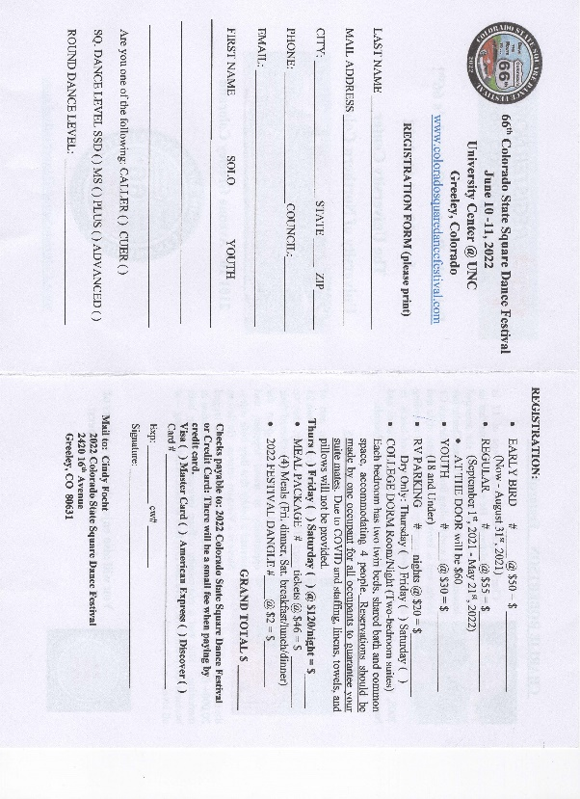
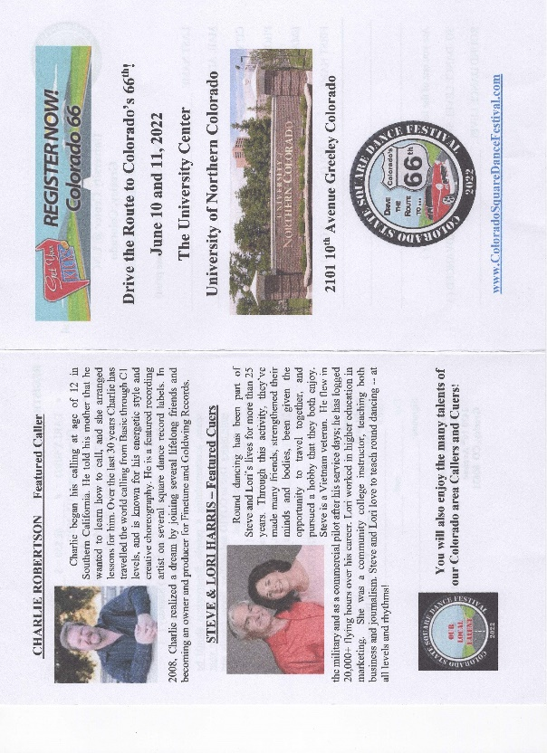
With Early-Bird

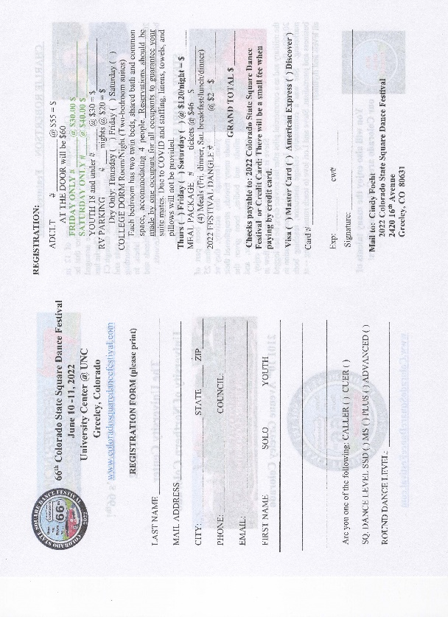
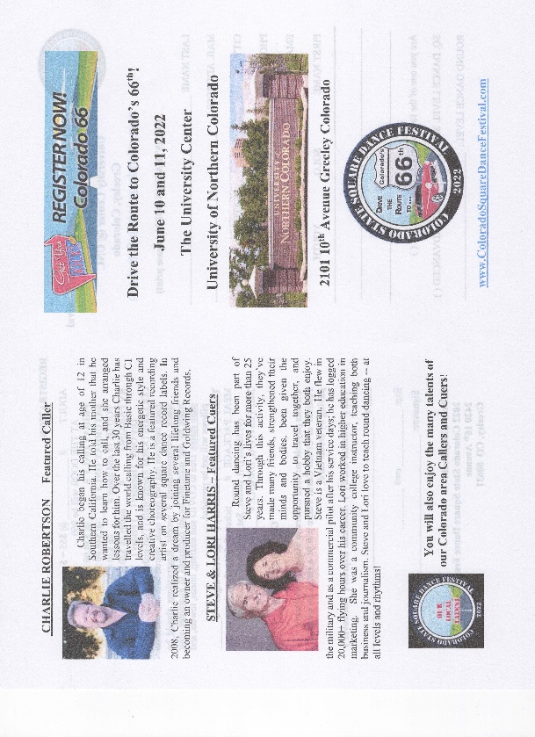
After Early-Bird

Appendix C
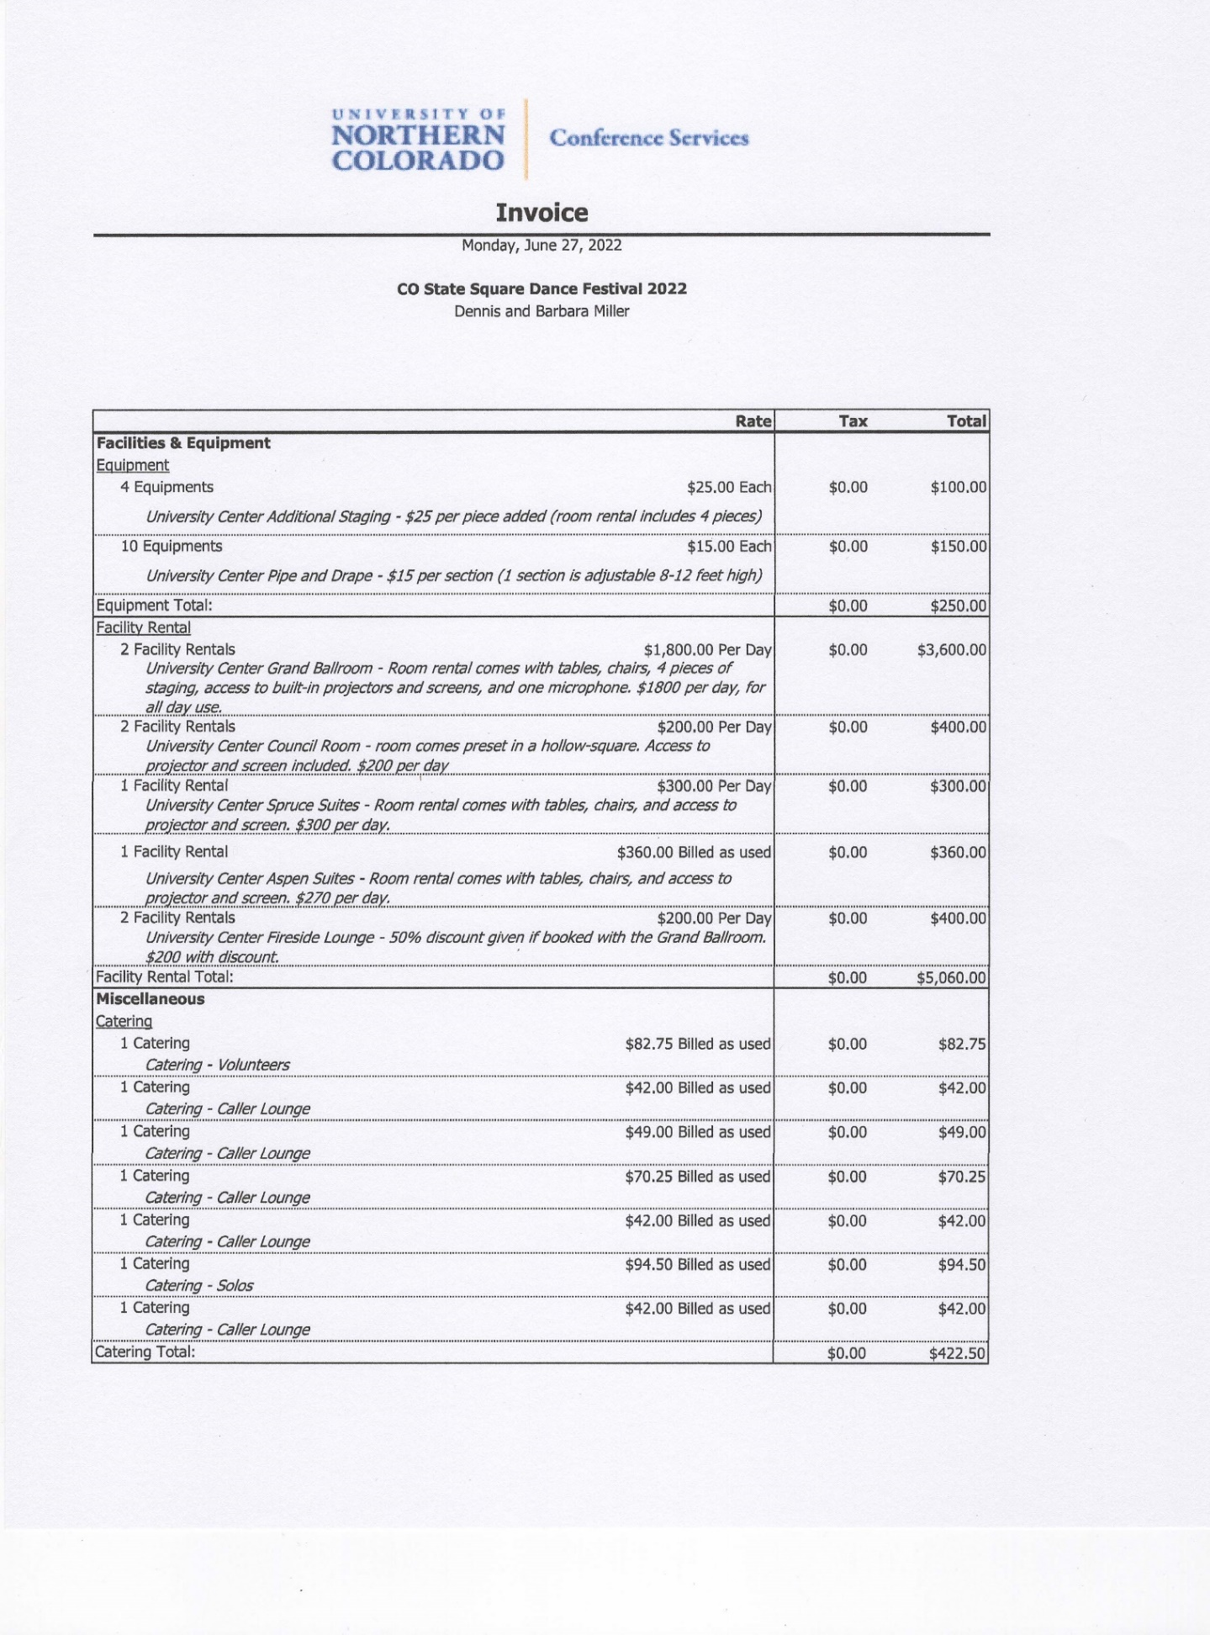

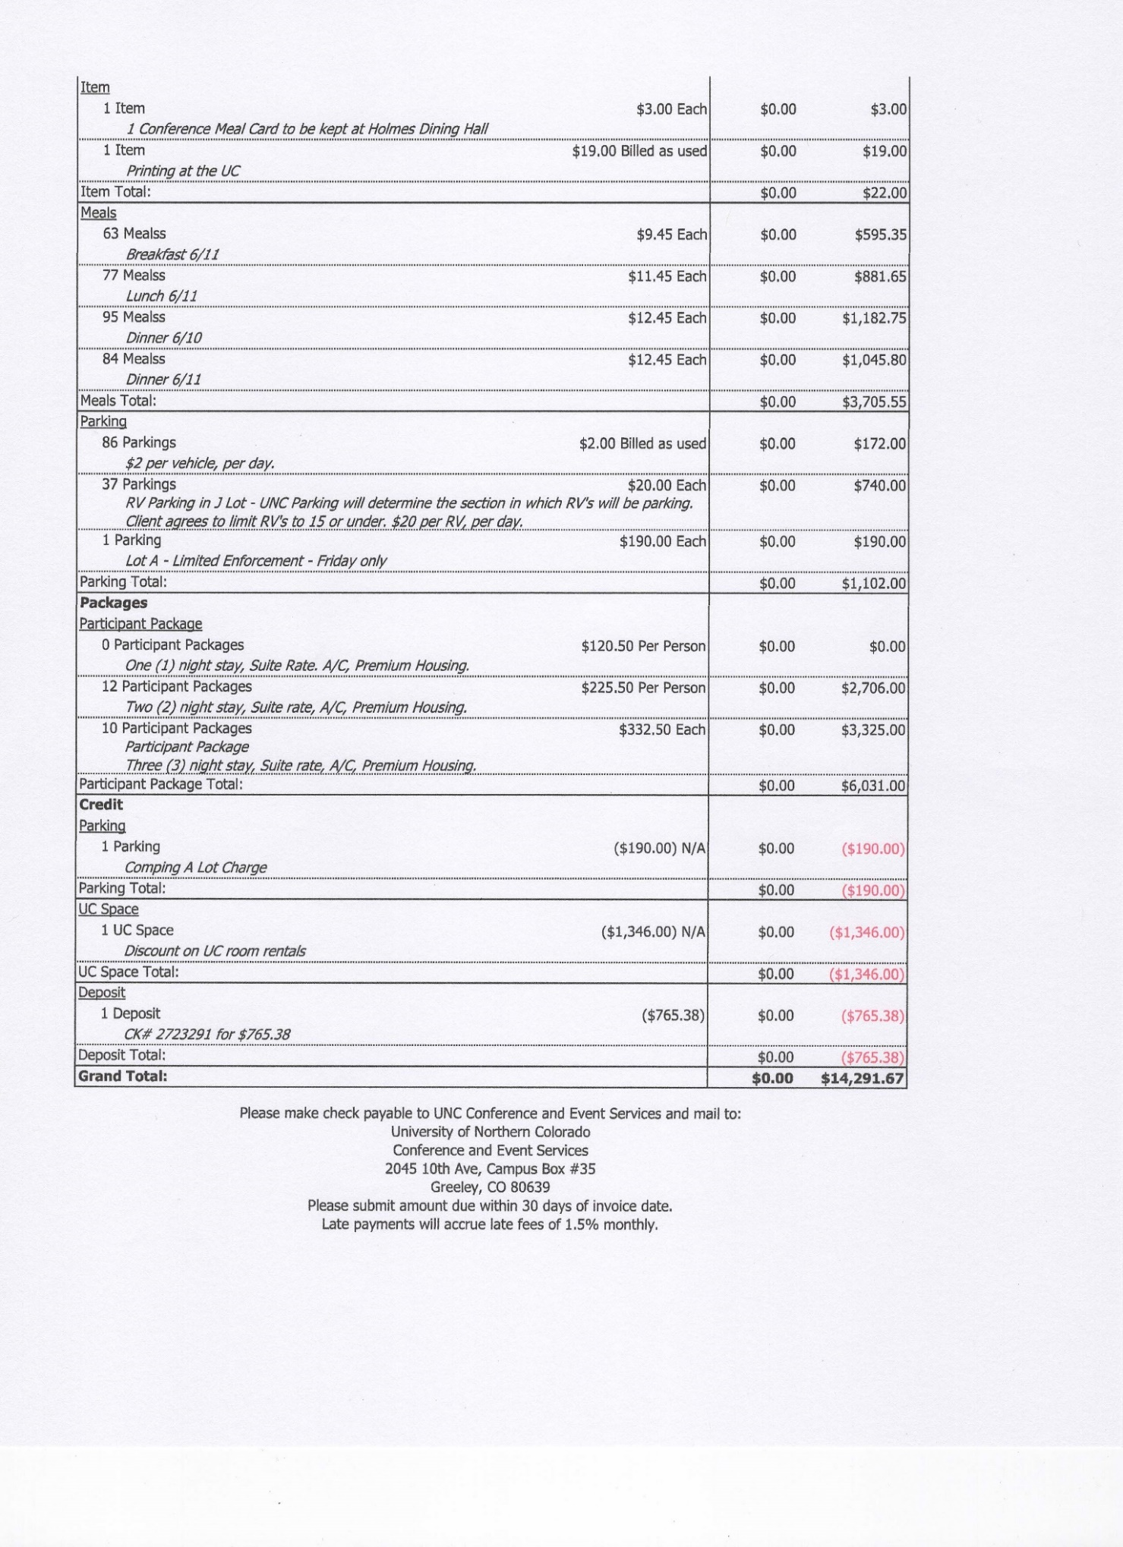

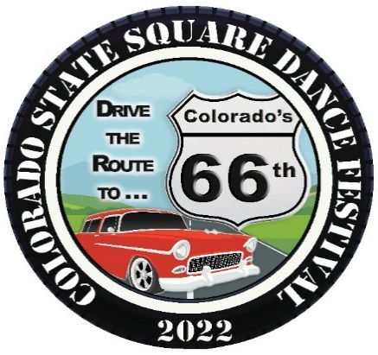

June 21, 2022

The University of Northern Colorado
Conferences Services
501 20th Street
Greeley, CO 80639

Dear Conference Services:

We are writing in reference to our contractual use of the University of Northern Colorado’s facilities and services by the Colorado Square Dance Association (Association) on June 10 and 11, 2022 for its annual State Square Dance Festival. First, we want to make it abundantly clear that the staff performed admirably in all our interactions with them! Overall, we were very pleased with our venue and had a successful event. We have provided a detailed “Client Feedback” document to staff summarizing the strengths and weaknesses of our experience.

Given some of the weaknesses we experienced in specific areas, we are requesting that Conferences Services apply discounts to certain areas of your billing to the Association. The contractual categories and requested discounts are as follows:
Facility Rental Requested Discount: 10% of Amount Due
Miscellaneous – Meals Requested Discount: 10% of Amount Due
Parking Lot A Requested Discount: 30% of Amount Due
Packages – Participant Packages Requested Discount: 10% of Amount Due
Based on our records, the total discounts would amount to approximately $1,536. Thank you for your consideration of our request.

Once again, we enjoyed being on campus for our Festival and truly appreciated all the efforts the UNC staff made. This is the second time we held our Festival at UNC and we certainly look forward to working with you again in the future. Perhaps by then we will have put all the residual effects of the pandemic behind us and all the facility updates at the University Center will have been completed.

Warmest regards,

Dennis & Barbara Miller, Co-Chairpersons
2022 Colorado State Square Dance Festival
Dmill5050@comcast.net (970) 667-7330 (H)
Bmill4708@comcast.net (970) 218-7250 (D-cell)
(970) 635-2956 (B-cell)
1302 6th Street SE
Loveland, CO 80537

Attachment: Client Feedback

Strengths

- Event Coordinator: Ashley Leggewie
  - Prior to the event, communications throughout the process were excellent! Emails were promptly returned. Information was provided in a timely manner. Questions were answered in detail. Specific areas of excellence were:
    - Working through COVID-related issues
    - Parking and dormitory issues
    - The Friday night “Hootenanny”
  - During the Event, Ashley was present and active to ensure success! She helped with signage for parking and dorms. She was an on-the-spot problem solver. Specific examples of excellence were:
    - Clearing up confusion at the registration desks
    - Getting room assignments straightened out
    - Getting plumbing issues resolved
    - Creating a “buffer” for our dancers from the BB camp attendees
    - Ensuring a smooth transition when ballroom configurations were to happen
    - Checking with us often to be sure things were going well

- Campus Security: UNC Police
  - Watched over our campers in Lot J
  - Were present on campus in numerous ways
  - Always friendly, courteous, and helpful

- Dormitory
  - Staff worked diligently to get folks registered quickly and into their rooms
  - Challenges and “glitches” were resolved satisfactorily
  - Staff was always customer-service oriented, courteous, and available

- Food Service
  - Despite a record-setting camp and square dancers, lines moved quickly
  - Food islands were always accessible and servers were helpful
  - Dining room at Holmes was clean and easy to maneuver
  - Food was, for the most part, tasty and plentiful
  - Environment for conversation and fellowship at meals was pleasant
  - Catering arrived on time; ordered items arrived in good shape and tasty

- Facility
  - Initial room set-up was done exactly right (according to our plans)
  - Rooms were clean and ready for Saturday
  - Requests were heard and responses were timely
  - Security was handled well and all dancers felt safe
  - Signage for parking lots and RV were placed in visible locations

Weaknesses

- Dormitory Amenities & Check-in Procedure
  - Due to COVID and staffing shortages, linens were not provided
  - No discount on suite rates were offered despite cutbacks in facility quality
  - Much confusion regarding check-in; multiple desks, halls, etc.
  - We understand that this situation was out of the staff’s control

- Construction Noise
  - All day on Friday of Festival there was considerable noise that interfered with conversations in the Lounge and vendor activities
  - We understand that this situation was out of the staff’s control

- Parking Lot A Restrictions
  - Approximately 30 parking spaces in Lot A were not available to our dancers due to the landscaping work going on
  - Participants were required to purchase parking passes due to fewer spaces available in Lot A
  - No discount on lot rental was offered despite less capacity available
  - We understand that this situation was out of the staff’s control

- Cafeteria Closure
  - Due to construction, the cafeteria on the lower level in the University Center was not available
  - This was a key feature in the success of the 2017 Festival
  - Those buying a weekend meal ticket had to walk approximately ½ mile to Holmes Dining Hall. This detracted from dance time and was hazardous for senior citizens based on excessive outdoor temperature and distance
  - No discount on meal prices were offered due to these inconveniences
  - We understand that this situation was out of the staff’s control

- Food Vendor Closures
  - When we were informed of the dining room closure (see above), we learned that the food vendors on the lower level would be open for the Festival (e.g. Munchie Mart, Einstein’s, and Subway. This would have given our dancers the option of eating at the University Center and avoiding the walk to Holmes.
  - The vendors did not open for the weekend!
  - We are not sure why this happened, but it may have been the vendors’ decision since school was not in session. We had hoped that staff could have recommended that the vendors remain open for Festival business.

- Excessive Heat
  - Greeley set an all-time heat record of over 100 degrees. Unfortunately, the HVAC system in the University Center could not keep up with the need. Our dancers were extremely uncomfortable and there were many complaints.
  - Ashley communicated our concerns and we were told that electricians worked on the issue Friday night. Things were pretty much the same on Saturday.
  - There was no AC in the Lounge on Friday and it was limited on Saturday.
  - We understand that this situation was largely out of the staff’s control.

Appendix D
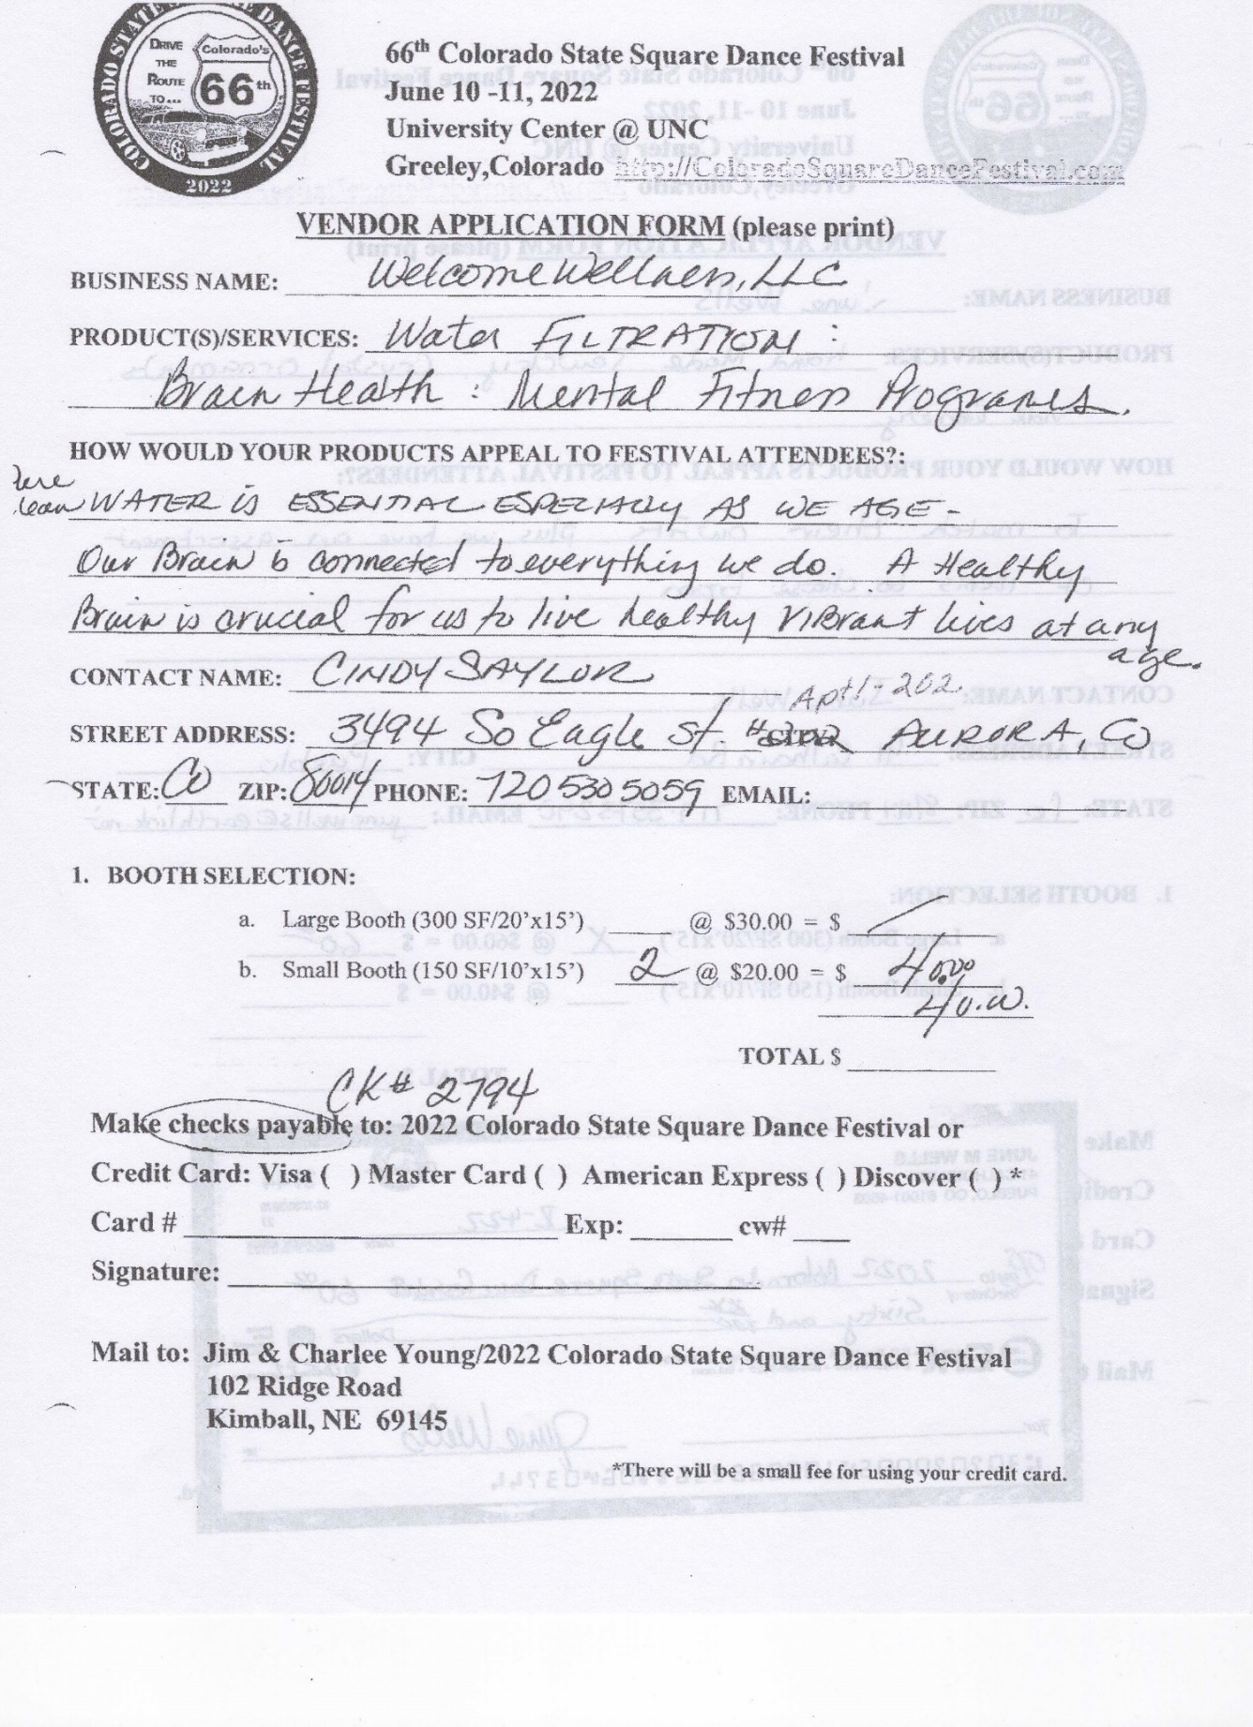

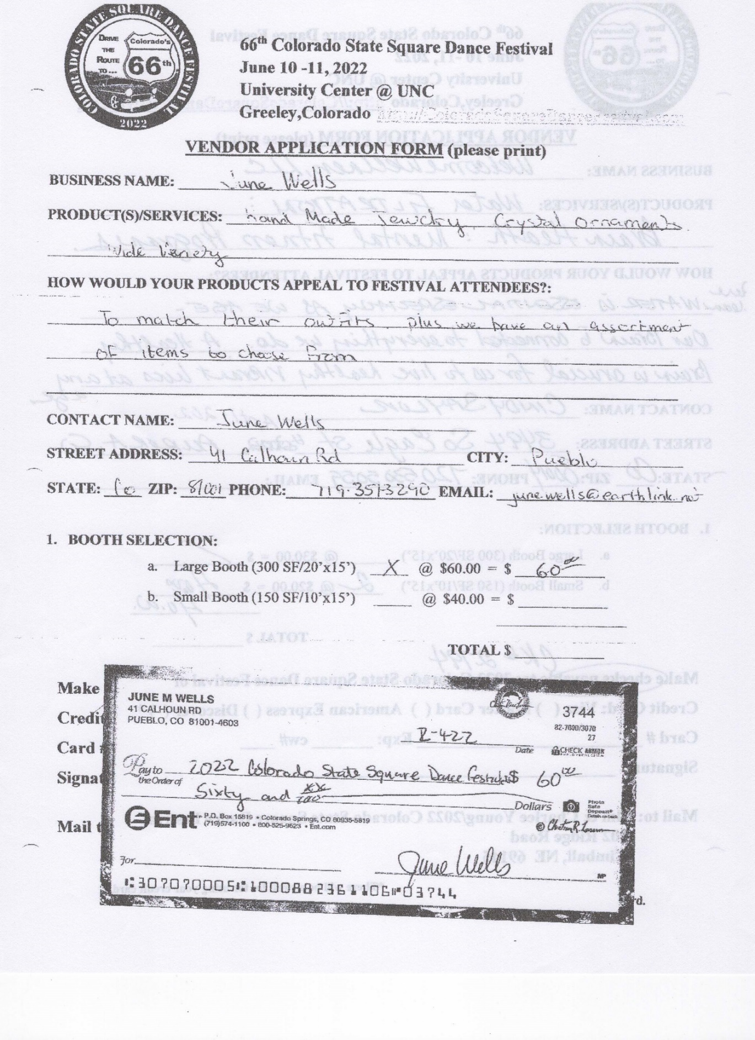

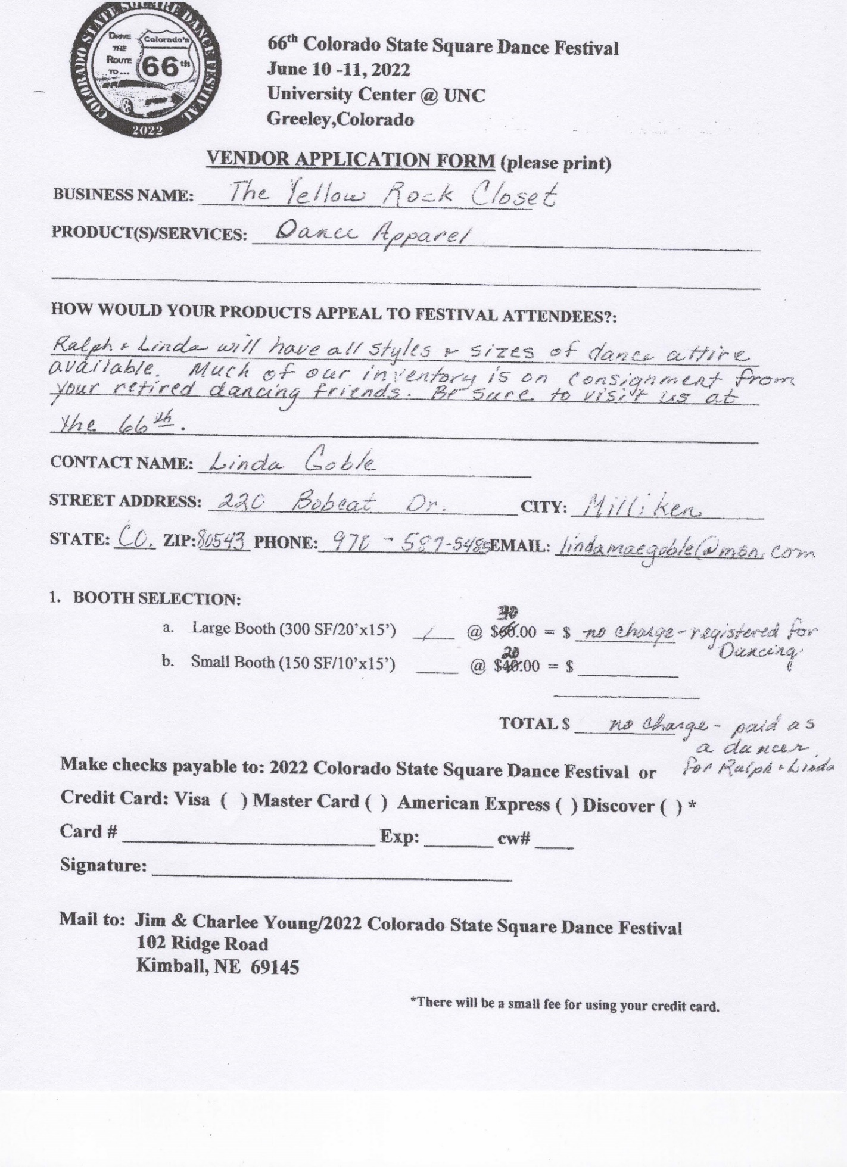

Appendix E
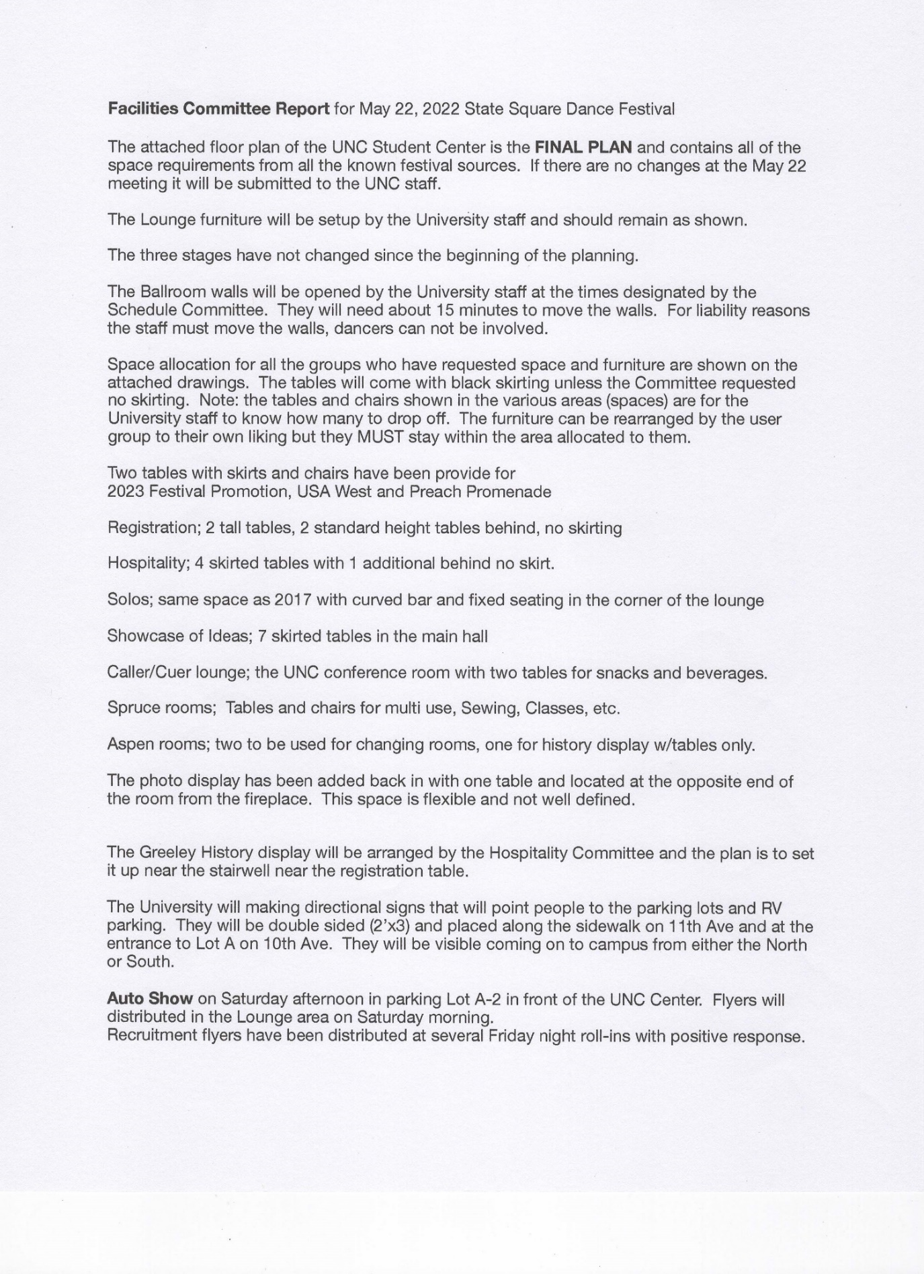

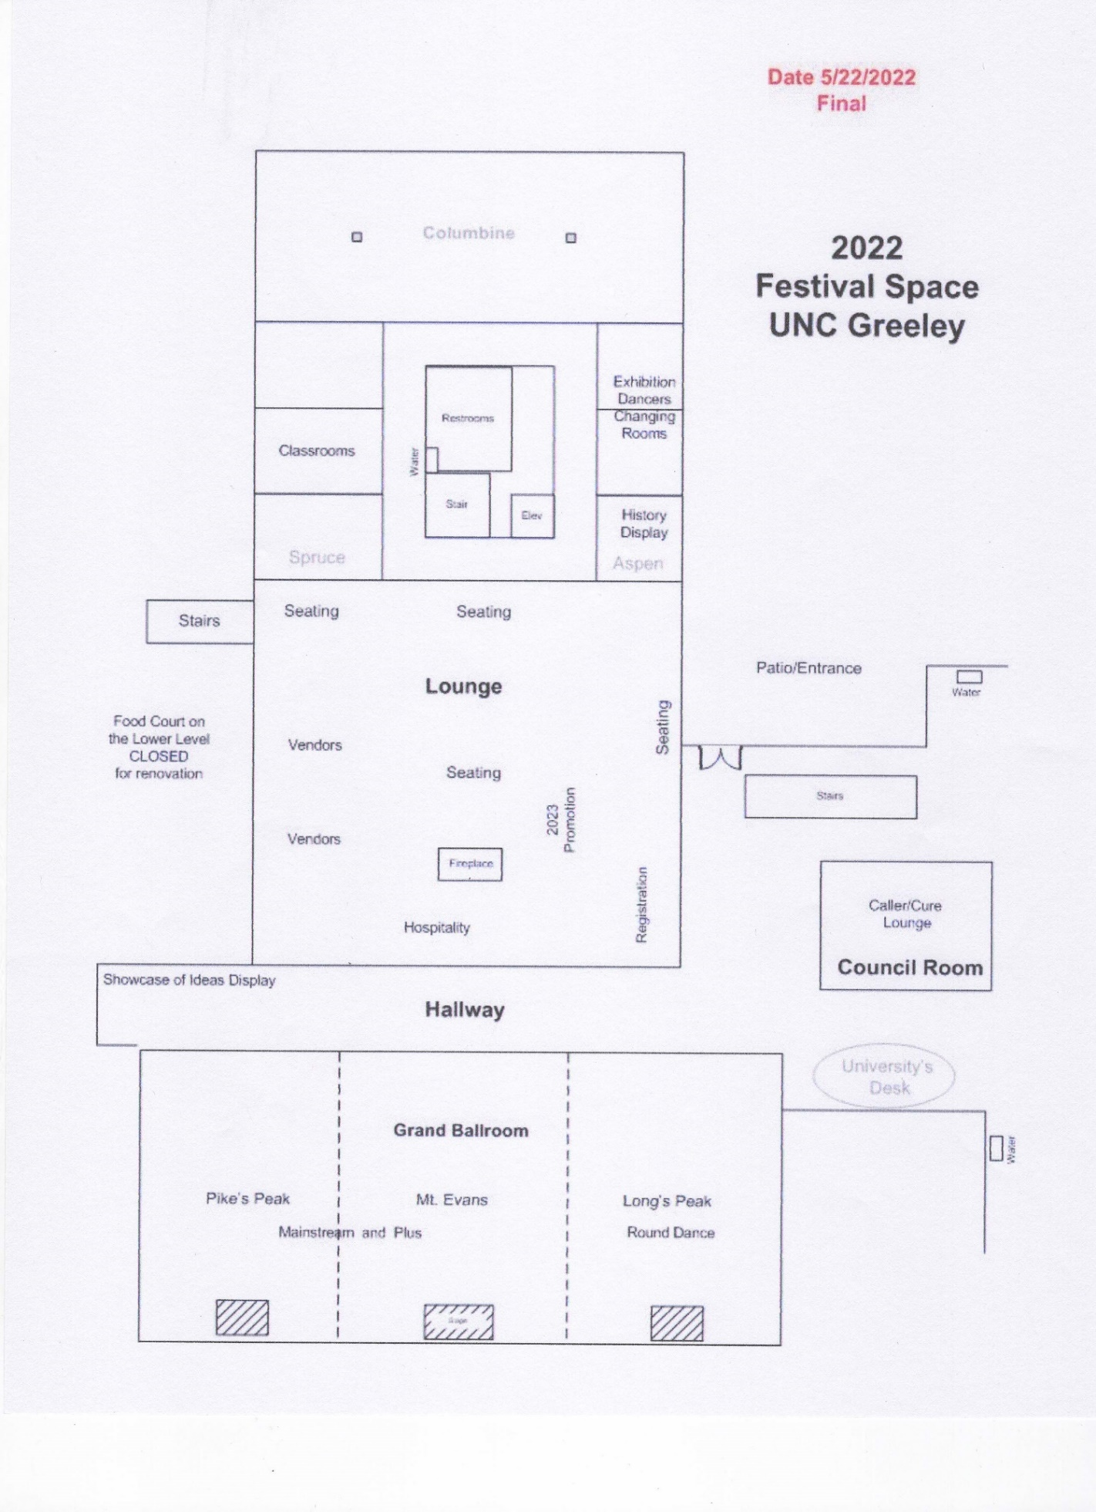

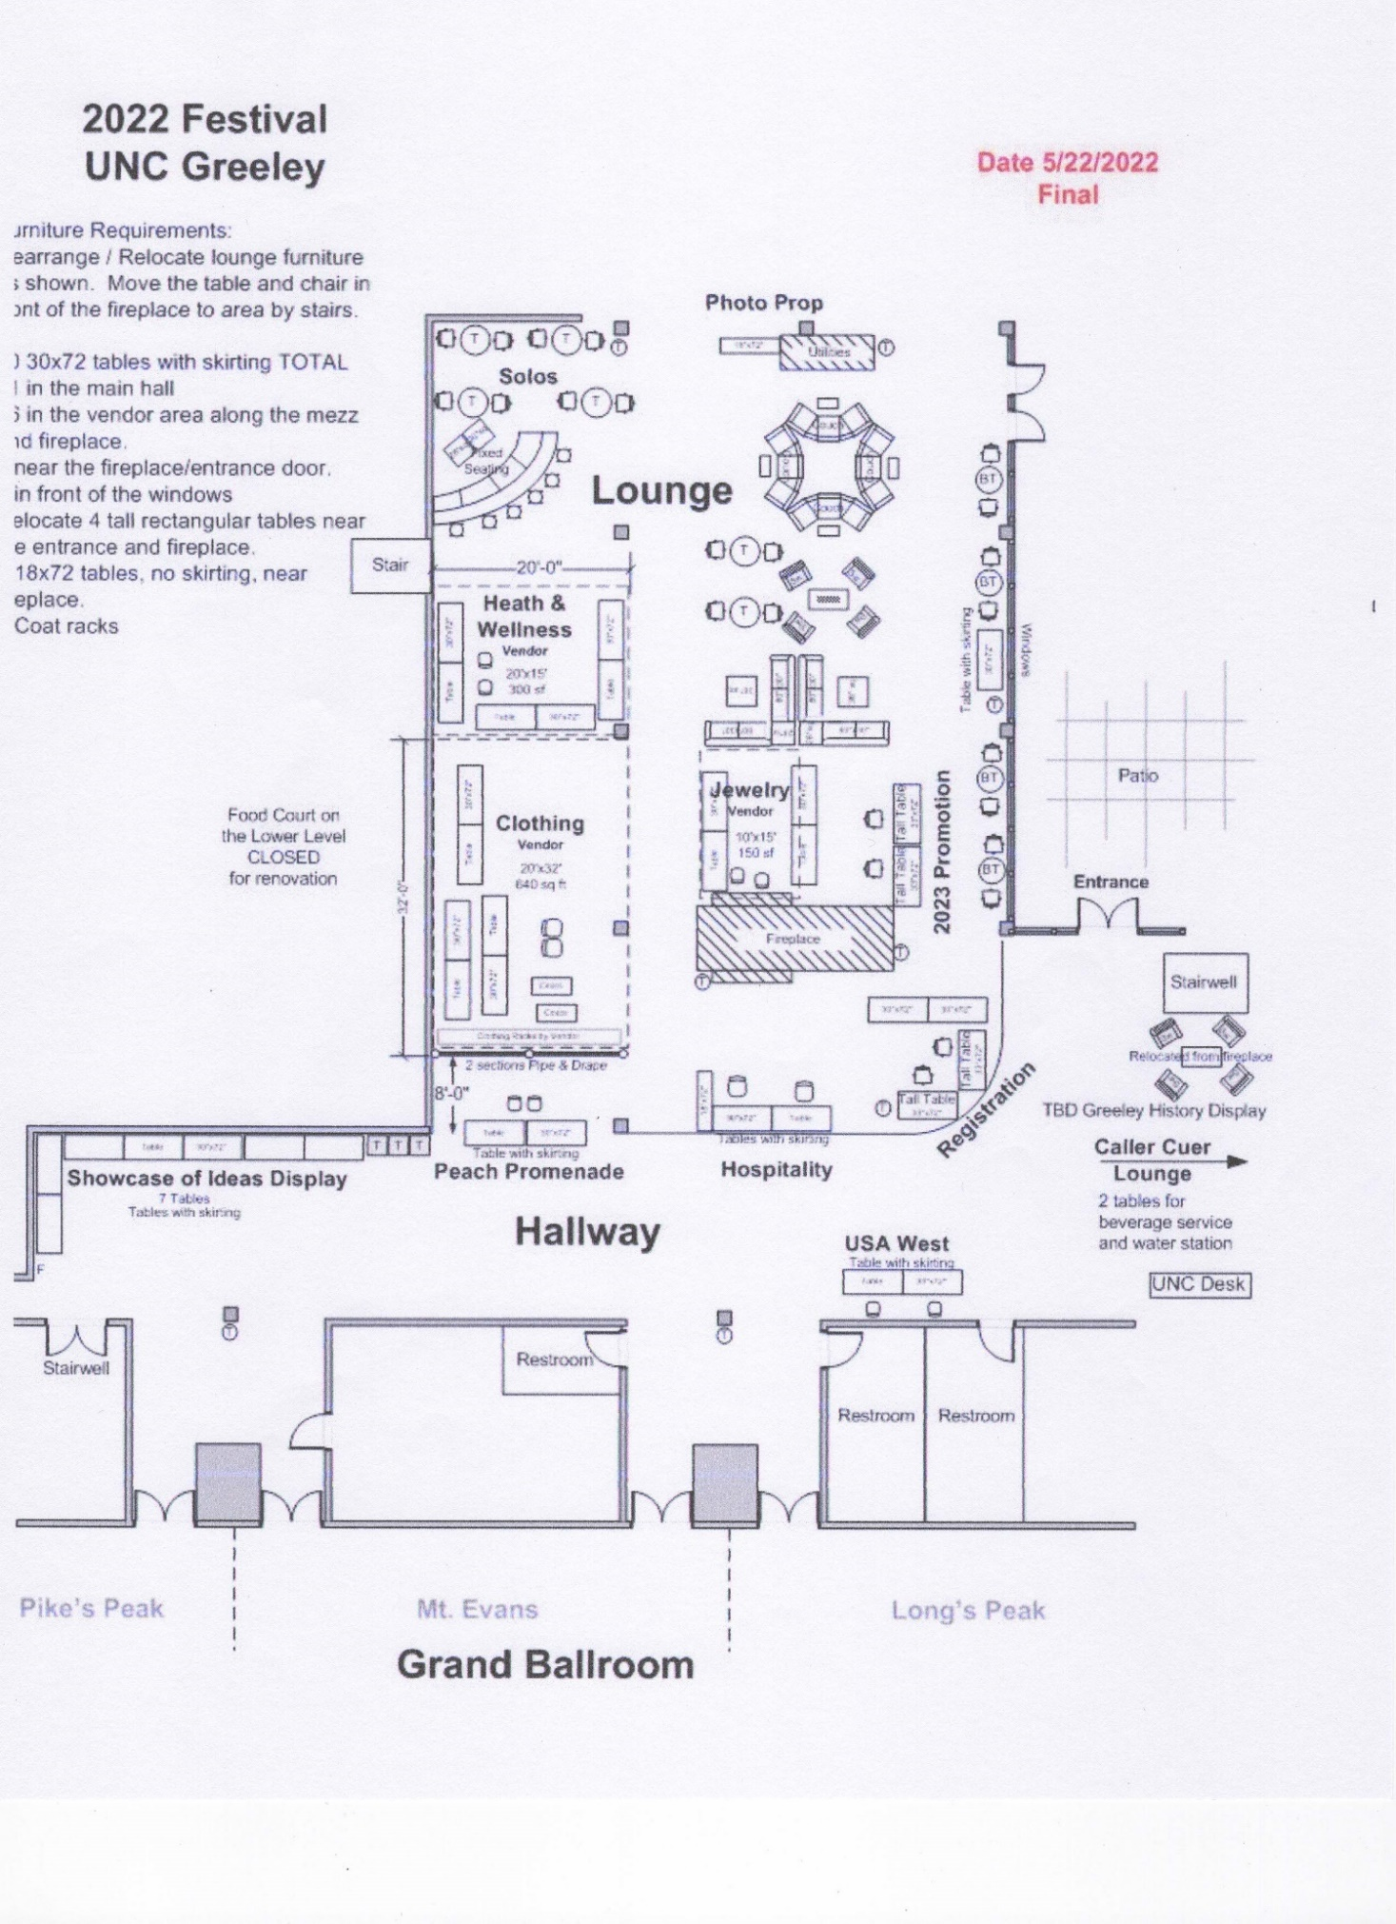

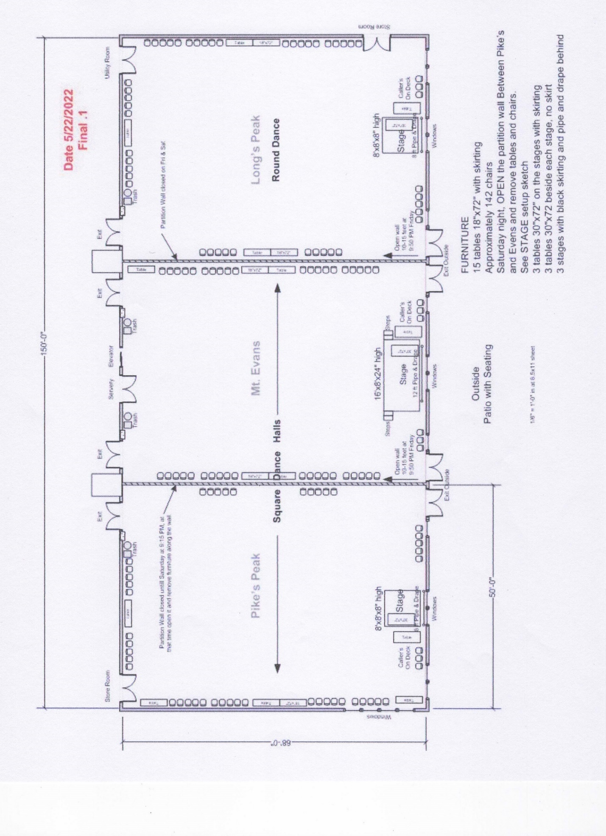

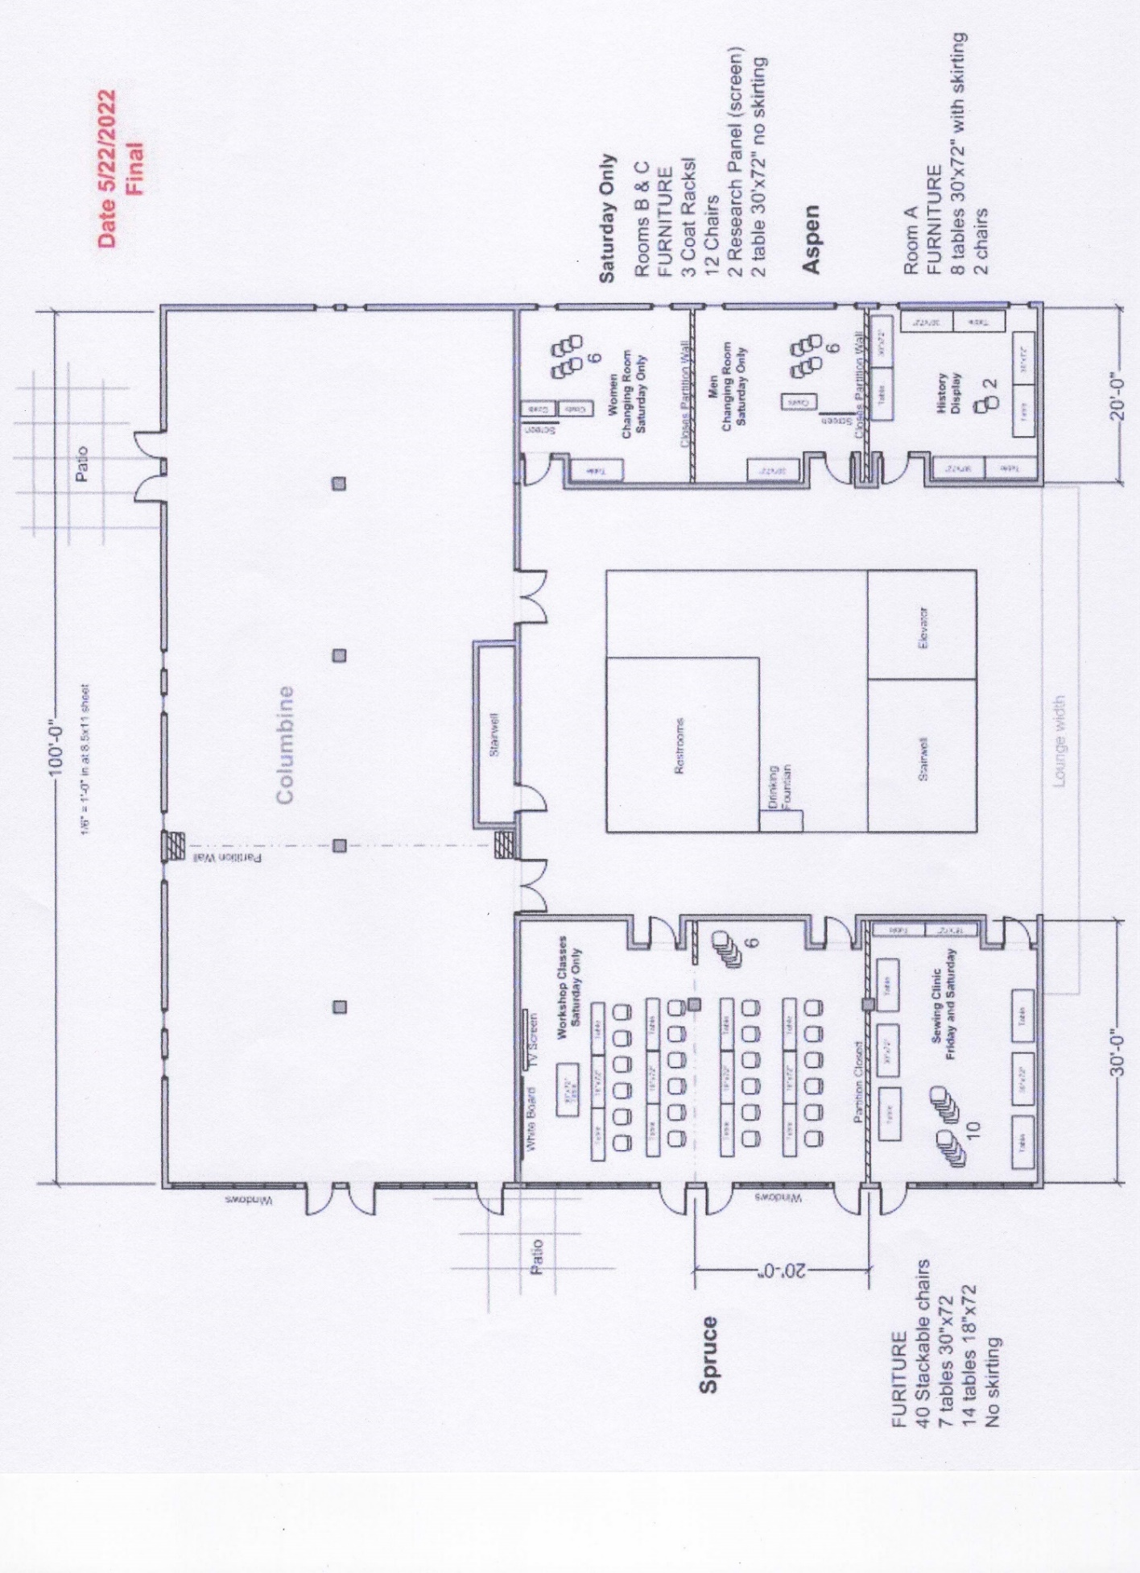

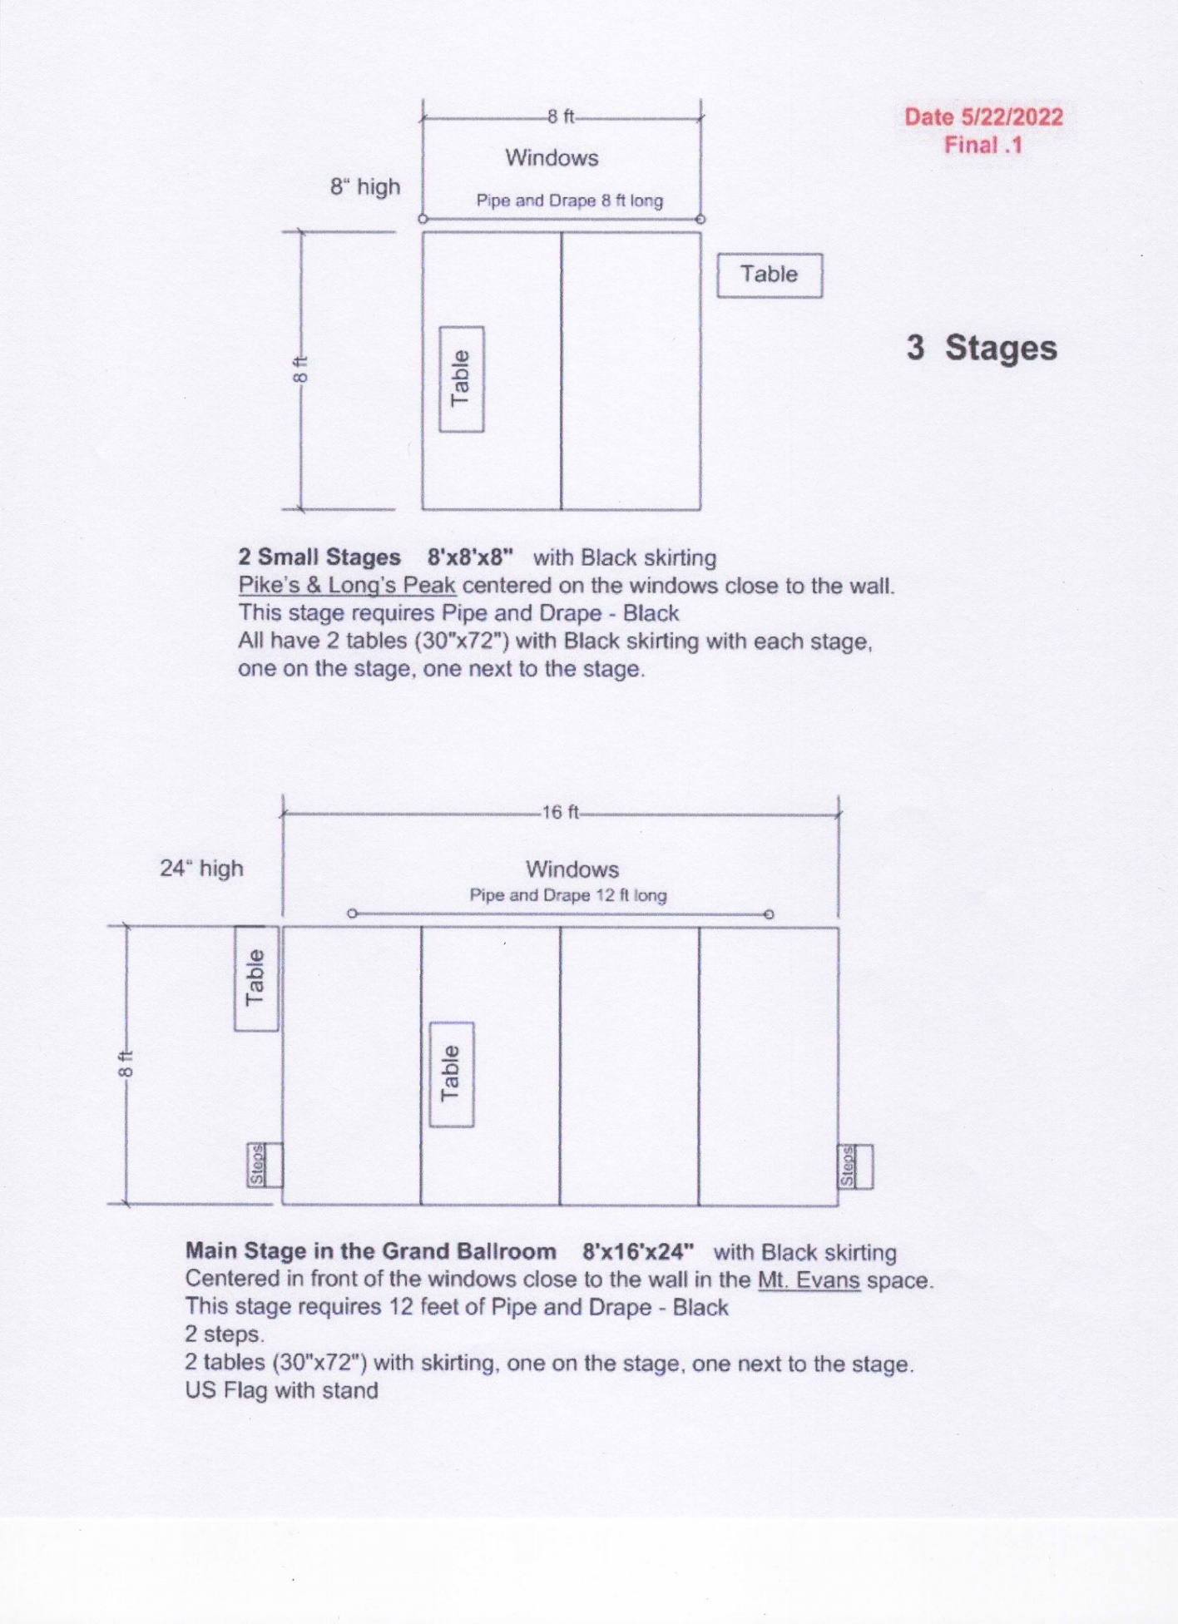

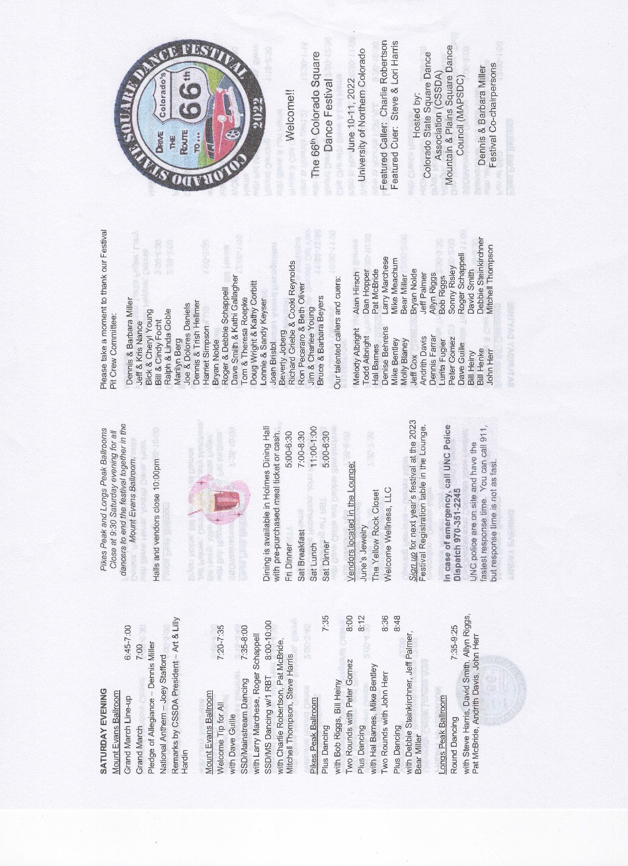
Appendix F

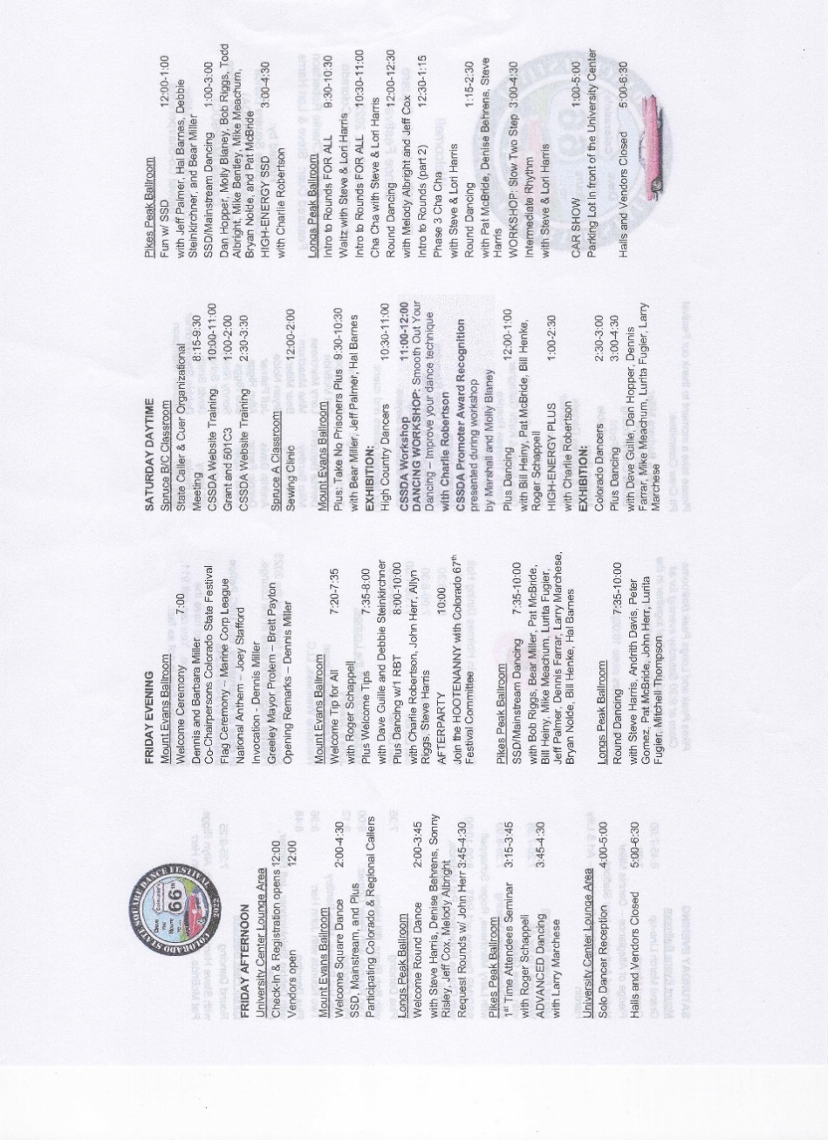

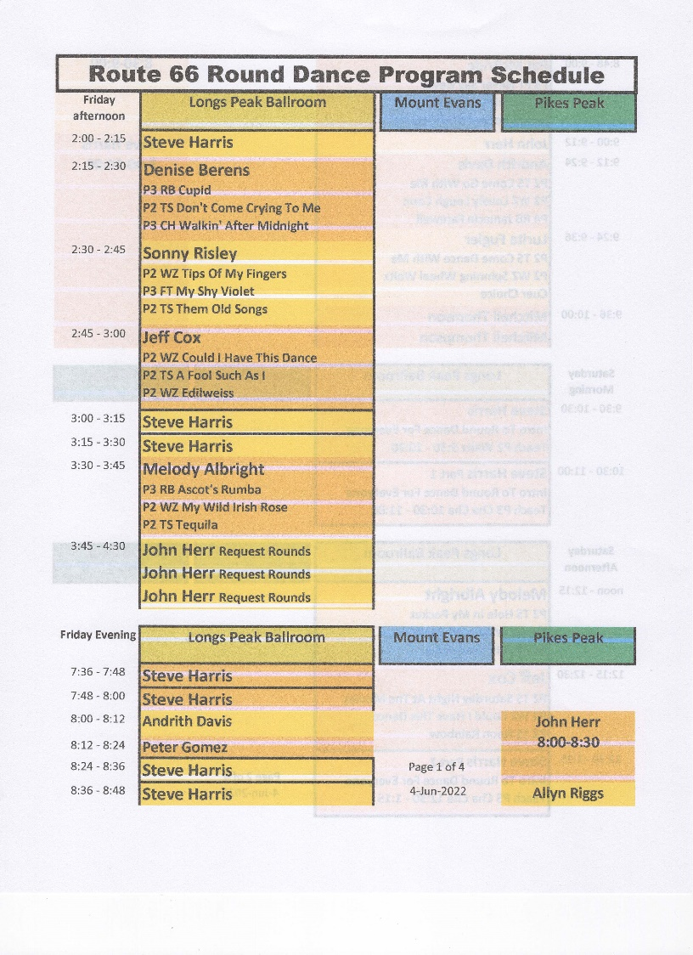
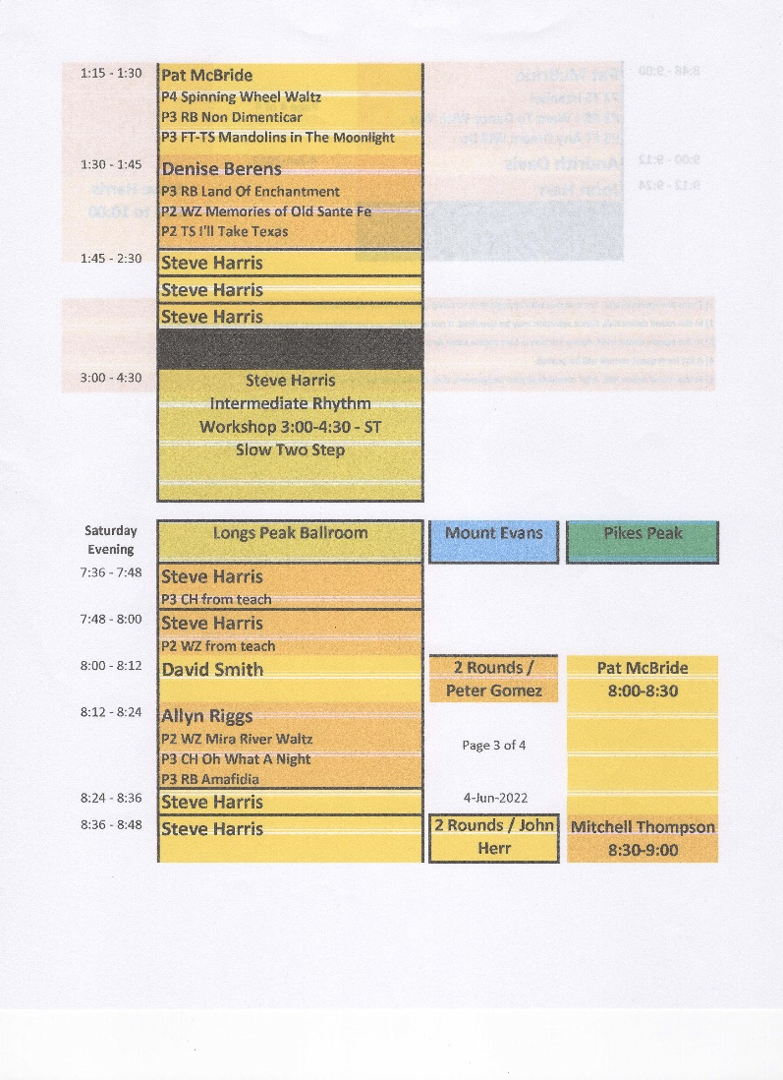

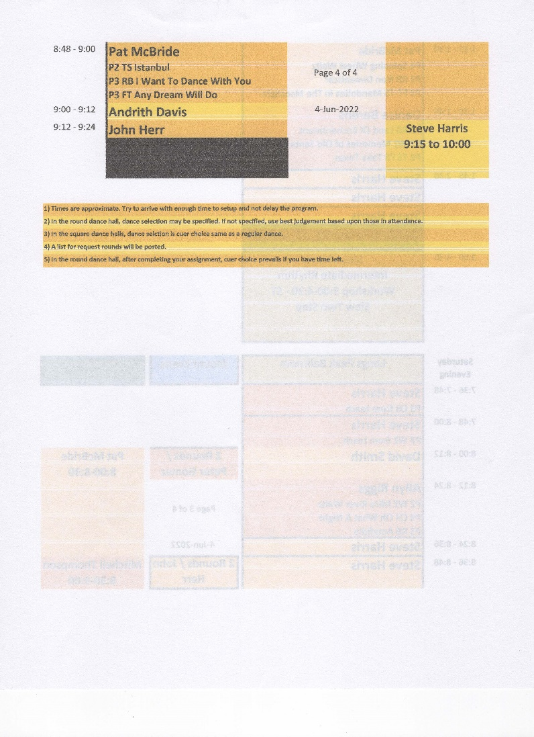
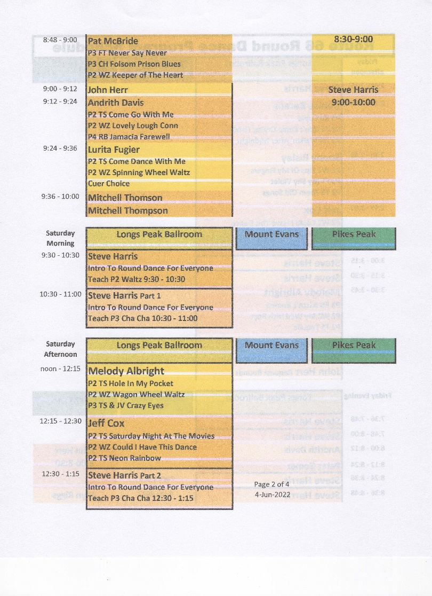

Appendix G

